Warm-Up: Plessy v. Ferguson (1896)

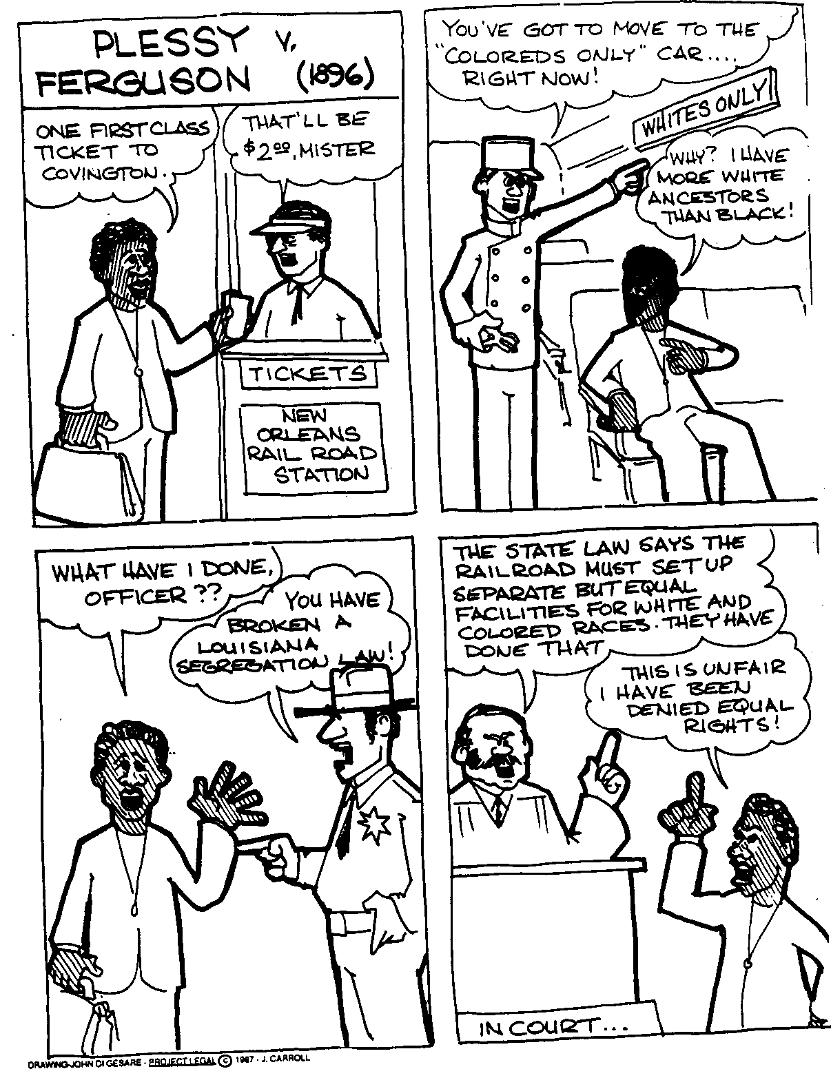

- What action did Homer Plessy refuse to perform that led to his arrest?

- What crime did Homer Plessy commit?

- What did the law require railroads to provide on their trains? Would this save or cost them more money?

- What argument did Plessy make in arguing against the Separate Car Act?

